Contents

Cloud Implementation Overview Model 2

Additional Details on the cloud concept of operations 3

Service Model(s) 4

SaaS 5

PAAS for Applications: 5

Discuss on how the selected Service Model/s can deliver intended set of workflows. 6

Security, storage of data, Accessibility, Scalability, and Efficiency: 6

Data Analytics: 6

Payroll and reporting Automation: 7

Deployment Model(s) 7

Infrastructure and cost involved: 8

Pricing Model – Comparison of pricing 11

Cloud Provider 1(AWS) 11

Cloud Provider 2(Azure) 11

Cloud Provider 3(Google) 12

Cost Management 13

Security risks and countermeasures 16

Challenges for the business process 16

Conclusion 17

Group Activity Report 17

References: 19

# 

# Cloud Implementation Overview Model

Air Cinema, operating in the movie theatre industry, currently relies on manual processes to manage customer records, which is becoming less efficient in today's digital age. To address these challenges, Air Cinema needs to transition to automated systems to streamline operations, offer 24/7 services, and reduce the necessity for physical visits.

Cloud-based solutions can be pivotal in transforming how Air Cinema operates. By adopting these solutions, the company can introduce online ticket booking, enhance accessibility, and elevate the overall customer experience. Cloud technology also provides a secure and efficient data storage solution, ensuring scalability, reliability, and compliance with security and privacy regulations.

To effectively compete in the global market, Air Cinema should consider implementing a Hybrid Cloud model, which combines SaaS and PaaS service models. This approach optimizes various operations, including ticket booking, payroll management, reporting, data analytics, and storage, while eliminating limitations on customer reach.

The adoption of Software as a Service (SaaS) can help manage manual record-keeping, reporting, and payroll processes, reducing the workload and improving customer convenience. It can also support branding initiatives and enable targeted marketing campaigns.

Cloud technology offers several benefits, including behaviour analytics, which allows for the collection and analysis of extensive customer data. This data-driven approach can significantly enhance decision-making and customer-focused strategies. To achieve this, incorporating Platform as a Service (PaaS) and SaaS service models is crucial.

Furthermore, to ensure the security of sensitive customer data, such as transaction details and credentials, the integration of Infrastructure as a Service (IaaS) and PaaS cloud service models is strongly recommended. This additional layer of security guarantees data protection and compliance with privacy regulations.

Currently, Air Cinema relies on manual ticket bookings and transactions, lacking an online booking system. This limitation restricts customer access and impacts operational efficiency. To address these challenges, Air Cinema should transition to cloud-based solutions, offering online booking and payment options and eliminating the need for physical visits. In conclusion, embracing cloud technology, particularly through the Hybrid Cloud model, will empower Air Cinema to effectively compete on a global scale. This transition will result in improved operational efficiency, an elevated customer experience, and robust data security and privacy measures. By making these changes, Air Cinema can position itself for success in the ever-evolving movie theatre industry.

# Additional Details on the cloud concept of operations

In current scenario AIR cinema is booking the tickets manually and following are the details related to traditional or current system that is followed in Air cinema:

* **Manual ledger or tax reporting challenges:** AIR Cinema currently uses manual record-keeping, which is time-consuming and inefficient. Switching to a cloud-based system would make things easier and more efficient. They should also improve their manual reporting and payroll processes to avoid delays in business operations.
* **Restricted reach:** Not using digital systems at AIR Cinema confines its outreach to a specific local market. Traditional methods prevent online advertising and 24/7 user access. The inability to perform consumer behaviour analytics impacts decision-making and confines services to the local market alone.
* **Lack of backup:** In case of disaster there is not any kind of backup available with the company that is affecting the reliability of the different business operations. This company has lack of records that can be useful for AIR cinema
* **Manual invoice generation:** Manual invoice generation is followed in AIR cinema that is affecting the timeliness of the different business operation. If this AIR cinema wants to serve the dynamic requirement of the client then they need to switch to the automatic invoice generation system.

To address the challenges posed by Air Cinema's traditional system, transitioning to the cloud is recommended. Implementing both Software as a Service (SaaS) and Platform as a Service (PaaS) will alleviate the need for manual record-keeping and enhance the tracking of customer requirements. This cloud migration aims to provide improved customer access and experiences, achieve timeliness through automated operations, and offer scalability, reliability, customer-oriented decision-making, and enhanced security. Notably, it enables a more engaging customer experience and broader audience reach, facilitating customer retention across diverse markets for Air Cinema.

*Figure: Hybrid cloud model for Air cinema*

# Service Model(s)

Moving the firm, Air Cinema, to a cloud-based service model that uses SAAS for virtual machines, storage, and networks and PAAS for apps will assist optimize IT resources and dramatically improve business operations. Here's how each service model can deliver the intended set of workflows and benefit the air cinema organization:

## SaaS

1. **Cost Savings:** By using SAAS solutions for virtual machines, storage, and network management, air cinema can save the capital costs involved with acquiring and maintaining real hardware. This saves money since we just pay for the resources we utilize (Benzina, K. (2019).
2. **Scalability: Scalability** is typically provided by SAAS providers, allowing to easily respond to changing resource requirements. This scalability guarantees that IT resources may expand, or contract as needed, which is especially important for a company like Air Cinema, which may face changing demand throughout different seasons or events.
3. **Reliability and redundancy:** This are ensured by reputable SAAS suppliers. This reduces the likelihood of downtime or data loss for important IT resources, enhancing overall reliability for company operations.
4. **Security and Compliance:** SAAS suppliers make significant investments in security and compliance certifications. By utilizing these services, may improve data security and regulatory compliance, which is critical for a company like Air Cinema that handles sensitive material (Determann, L. (2014).
5. **Resource Optimization:** Because the supplier handles maintenance and updates, SAAS allows to deploy IT resources more efficiently. Instead of regular system management, internal IT staff may concentrate on strategic activities.

## PAAS for Applications:

**a. Rapid Development:** PAAS provides a framework for rapidly building and deploying applications. This allows Air Cinema to adapt to market demands more quickly, giving them a competitive advantage.

**b. Application Scaling:** PAAS platforms can handle application scaling automatically based on demand, guaranteeing that programmed can handle growing usage without manual intervention.

**c. Integration Capabilities:** PAAS systems frequently have pre-built connectors and APIs that make it easier to link apps to other services or data sources. This can improve organization's overall efficiency and data communication.

**d. Lower Development Overhead:** Because PAAS abstracts most of the infrastructure administration, development teams can focus on code and innovation rather than server settings and maintenance.

**e. Cooperation:** PAAS systems frequently promote cooperation across development teams, which can contribute to faster app development cycles and better communication within the organization.

# Discuss on how the selected Service Model/s can deliver intended set of workflows.

Based on the identified reasons for migrating to a cloud-based infrastructure, here are the specific needs and requirements for the migration, including deployment models and service models:

## Security, storage of data, Accessibility, Scalability, and Efficiency:

**- Service Model: Platform as a Service (PaaS) or Infrastructure as a Service (IaaS)**

**- Deployment Model: Hybrid Cloud**

**Details:** To safeguard customer information and enhance security, AIR Cinema could opt for IaaS and PaaS cloud services. These choices would ensure the protection of transaction details, ticket information, and customer credentials. By implementing end-to-end encryption and appropriate authentication methods, trust can be established. IaaS offers benefits like accessibility, scalability, reliability, and efficiency. Adapting to the ever-changing market and efficiently managing high volumes of customers is simplified with these cloud services. Furthermore, they address security and fraud concerns effectively. This transition to the cloud aligns with AIR Cinema's global expansion objectives, enhancing scalability and efficiency in serving a large customer base simultaneously. Online ticket booking System and Increasing the reach to global market:

**- Service Model: Software as a Service (SaaS)**

**- Deployment Model: Hybrid Cloud**

**- Details:** Air Cinema requires online ticket booking system that helps to reduce the waiting time of the customer to book ticket. This system will help the customer to cancel the ticket, to book the ticket, to pay online, to pre-book the tickets and to search out the different movies and shows available. SaaS provides the services related to searching the new products and items for online booking. To avoid the issues of restricted reach of the Air Cinema to local market the branding of the Air Cinema can be done via SaaS services cloud.

## Data Analytics:

**- Service Model: Platform as a Service (PaaS)**

**- Deployment Model: Hybrid Cloud**

- **Details:** Air Cinema needs to make decisions based on data and what customers want. They can do this effectively using cloud-based tools. These tools help them understand customer behaviour and preferences. One important tool is Platform as a Service (PaaS), which lets them analyse data and customer behaviour. They can also use a recommender system to make better decisions based on data. By using these tools, Air Cinema can stay competitive, reach more customers, and make better choices that customers will like.

## Payroll and reporting Automation:

**- Service Model: Software as a Service (SaaS)**

**- Deployment Model: Hybrid Cloud**

**Details**: Air Cinema can use SaaS (Software as a Service) to simplify tasks like record-keeping, reporting, and payroll for employees. SaaS allows for online booking, payments, and 24/7 access. It also offers easy access, storage, and ticket tracking for the service owner. Employees can maintain customer records and customers can cancel tickets online.

Using SaaS helps Air Cinema reach a global market and gain competitive advantages, enhance branding, conduct marketing and market research. It automates operations and improves brand recognition internationally.

Automated payroll and reporting streamline salary and attendance processes, reducing manual work and errors. SaaS improves timeliness by saving time and effort. To serve the dynamic requirements of the customers in this era of technology following are the different imperatives that need to be recognised by the Air cinema official for a positive change:

1. **Enhanced Customer Convenience:** Air Cinema can cater to its clients' ever-changing needs by offering round-the-clock access.

2. **Punctuality:** Cloud-based solutions enable swift ticket reservations, ensuring timely operations.

3. **Streamlined Operations:** Automation boosts efficiency, enriches user experiences, and reduces manual tasks.

4. **Versatility:** The system adeptly handles increased customer demand, empowering Air Cinema to compete on a global scale.

5. **Dependability:** Cloud technology provides reliability across various services, expanding Air Cinema's outreach.

6. **Customer-Focused Decision-Making:** Cloud technology monitors customer interests, preferences, and history, facilitating better decision-making.

7. **Enhanced Security:** Cloud services offer superior data security, safeguarding sensitive information more effectively than traditional methods.

# Deployment Model(s)

Under Legal perspectives there are number of issues on which company need to focus such as cross border data transfer, lawful interception or information requests, encryption and data security, ownership of data and content regulation. Although the implementation of hybrid cloud model in Air cinema provides numerous opportunities for growth but following the number of challenges that can be faced by the officials of the Air cinema while implementing the cloud service in the Air cinema

1. **Cross border data transfer:** When sharing data internationally through cloud systems, companies must follow legal rules. The global nature of cloud technology can create legal challenges. Some countries, like Australia, are working on laws to address this, such as the CLOUD Act and Telecommunications Legislation Amendment (International Production Orders) Bill 2020, to ensure national security.
2. **Lawful interception or information requests:** The different countries have different policies related to data sharing because in case of crime they need to share the essential information that is stored on cloud; these kinds of requests are dependent on the location of the provider and the authority. In Australia different laws related to data request have been followed as information act, Australian privacy act and under these acts a framework has been proposed that delay with the issues related to disclosure of information across the border.
3. **Encryption and data security:** [Privacy Act 1988](https://www.legislation.gov.au/Series/C2004A03712), [Spam Act 2003 (Cth)](https://www.legislation.gov.au/Series/C2004A01214) and Do Not Call Register Act 2006 are the acts that are implemented by the Australian government to manage the risks related to encryption and data security.
4. **Ownership of data and content regulation:** ownership of the data is major challenge that needs to be considered while the migration of cloud and some of the well-known regulations related to data implemented by Australian government include the European Union’s General Data Protection Regulation (GDPR) and the California Consumer Privacy Act (CCPA) in California, U.S.

Some of the benefits are:

1. Scalability: It is able to utilise public clouds for scaling customer-facing applications as needed, making sure of the smooth performance during high traffic.
2. Data security and control: Sensitive data are within the private cloud. It provides the robust security measures and compliance with data protection regulations.
3. Cost efficiency: it optimises the costs by utilising the public cloud resources when needed reducing the costs.
4. Adaptability: It adapts to the changing environment.
5. Reliability: It minimises the downtime risks with failover capabilities and redundancy.
6. Compliance: It adhere the data protection regulations like GDPR and CCPA.

# Infrastructure and cost involved:

Following are the details of the resources and cost that is required for the completion of the project:

|  |  |  |
| --- | --- | --- |
| Task Name | Infrastructure | Cost |
| **Project Schedule** | Computers, laptops, mobile devices, tablets, desks server, router, switch, hub (networking equipment), wires, switches | **$46,400.00** |
| **Requirement collection and analysis** | **$5,720.00** |
| requirement elicitation | $1,440.00 |
| requirement analysis | $1,080.00 |
| feasibility study | $2,400.00 |
| planning completed | $800.00 |
| **Design phase** | **$11,880.00** |
| defining the IT assets | $3,840.00 |
| selecting cloud service model | $3,240.00 |
| designing the network and establishing the servers | $4,000.00 |
| designing completed | $800.00 |
| **Implementation and maintenance** | **$28,800.00** |
| implementing the network or data bases | $14,400.00 |
| implementing the cloud services | $10,800.00 |

Following are the details of the cost of human resources estimated for the completion of this project:

|  |  |  |  |
| --- | --- | --- | --- |
| **Name** | **Actual Work** | **Actual Cost** | **Standard Rate** |
| Jon | 0 hrs | $0.00 | $60.00/hr |
| Sonia | 0 hrs | $0.00 | $45.00/hr |
| Brian | 0 hrs | $0.00 | $50.00/hr |
| Jon/project manager | 24 hrs | $1,440.00 | $60.00/hr |
| Sonia/team member | 6 hrs | $270.00 | $45.00/hr |
| Brian/team member | 0 hrs | $0.00 | $50.00/hr |
| Brian team member | 0 hrs | $0.00 | $50.00/hr |
| Brian/ team member | 0 hrs | $0.00 | $50.00/hr |

# Pricing Model – Comparison of pricing

Successful cloud migration campaigns depend heavily on pricing strategies, just as any other business strategy does. Pricing in the cloud refers to the process of estimating how much it will cost to make use of various cloud service providers.

Cloud Provider 1(AWS)  
**Cloud Server**

|  |  |  |  |
| --- | --- | --- | --- |
| **Instances** | **vCPU** | **RAM** | **Price (AWS)** |
| Instance 1 | 2 | 8 GB | $0.1344 per hr |
| Instance 2 | 4 | 16 GB | $ 0.153 per hr |
| Instance 3 | 8 | 32 GB | $ 0.166 per hr |

**Cloud Storage**

|  |  |  |  |  |
| --- | --- | --- | --- | --- |
| **Data storage prices pay - as - you - go** | **Standard** | **Infrequent Access** | **Glacier** | **S3 Intelligent Tiering** |
| **First 50 terabyte (TB)/Month** | $ 0.023 per GB | $ 0.01 per GB | $ 0.004 per GB | $ 0.023 per GB |
| **Next 450 terabyte (TB)/Month** | $ 0.022 per GB | $ 0.01 per GB | $ 0.004 per GB | $ 0.022 per GB |
| **Over 500 terabyte (TB)/Month** | $ 0.021 per GB | $ 0.01 per GB | $ 0.004 per GB | $ 0.021 per GB |

## Cloud Provider 2(Azure)

**Cloud Server**

|  |  |  |  |
| --- | --- | --- | --- |
| **Detail** | **Core** | **RAM** | **Price (Azure)** |
| Instance 1 | 2 | 8 GB | $0.111 per hr |
| Instance 2 | 4 | 16 GB | $ 0.118 per hr |
| Instance 3 | 8 | 32 GB | $ 0.120 per hr |

**Cloud Storage**

|  |  |  |  |  |  |
| --- | --- | --- | --- | --- | --- |
| **Data storage prices pay - as - you - go** | **Premium** | **Hot** | **Cool** | **Cold** | **Archive** |
| **First 50 terabyte (TB)/Month** | $ 0.15 per GB | $ 0.018 per GB | $ 0.01 per GB | $ 0.0036 per GB | $ 0.00099 per GB |
| **Next 450 terabyte (TB)/Month** | $ 0.15 per GB | $ 0.0173 per GB | $ 0.01 per GB | $ 0.0036 per GB | $ 0.00099 per GB |
| **Over 500 terabyte (TB)/Month** | $ 0.15 per GB | $ 0.0166 per GB | $ 0.01 per GB | $ 0.0036 per GB | $ 0.00099 per GB |

## Cloud Provider 3(Google)

**Cloud Server**

|  |  |  |  |
| --- | --- | --- | --- |
| **Detail** | **vCPU** | **RAM** | **Price (Google)** |
| Instance 1 | 2 | 8 GB | $0.004 per hr |
| Instance 2 | 4 | 16 GB | $ 0.015 per hr |
| Instance 3 | 8 | 32 GB | $ 0.066 per hr |

**Cloud Storage**

For buckets located in a single region:

|  |  |  |  |
| --- | --- | --- | --- |
| Storage Class | Class A operations (per 1000 operations) | Class B operations (per 1000 operations) | Free operations |
| Standard storage | $ 0.005 | $ 0.0004 | Free |
| Nearline storage | $ 0.01 | $ 0.001 | Free |
| Coldline storage | $ 0.02 | $ 0.01 | Free |
| Archive storage | $ 0.05 | $ 0.05 | Free |

For buckets located in a dual region or multi region:

|  |  |  |  |
| --- | --- | --- | --- |
| Storage Class | Class A operations (per 1000 operations) | Class B operations (per 1000 operations) | Free operations |
| Standard storage | $ 0.01 | $ 0.0004 | Free |
| Nearline storage | $ 0.02 | $ 0.001 | Free |
| Coldline storage | $ 0.04 | $ 0.01 | Free |
| Archive storage | $ 0.10 | $ 0.05 | Free |

*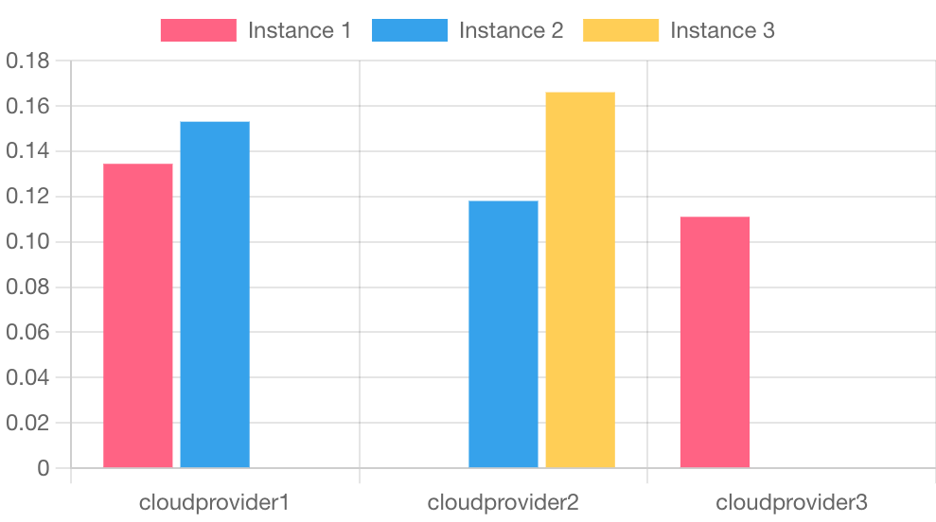Figure: Price comparison of three cloud providers*

# Cost Management

Gantt chart is used to represent the cost of implementation for this project in Air cinema, there are different phases of migration and the total cost that is required for the completion of this project **$46,400.00 comprises the cost of resources required such as** Computers, laptops, mobile devices, tablets, desks server, router, switch, hub (networking equipment), wires, switches etc.

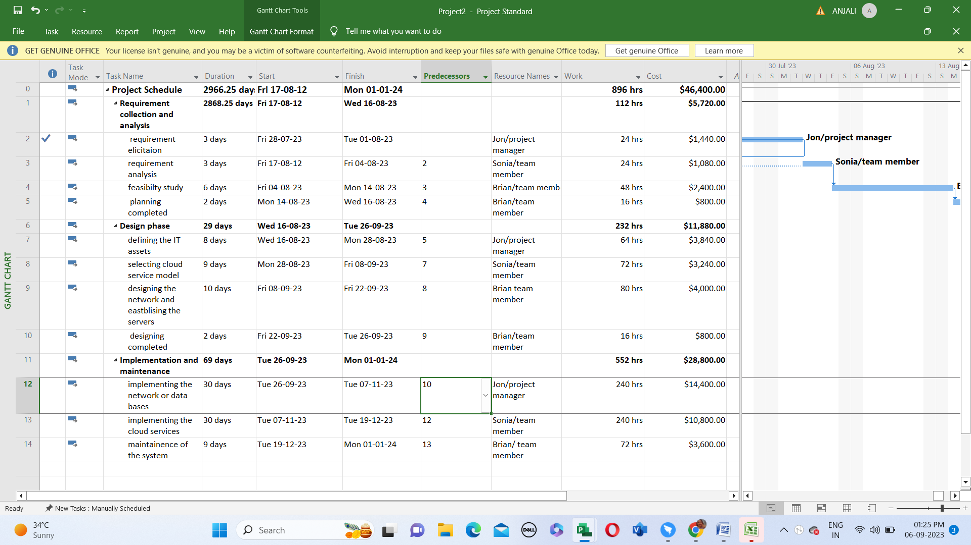

*Figure: Cost management of different phases involved in the project*

|  |  |  |  |  |  |  |  |
| --- | --- | --- | --- | --- | --- | --- | --- |
| Task Name | Duration | Start | Finish | Predecessors | Resource Names | Work | Cost |
| **Project Schedule** | **2966.25 days** | **Fri 17-08-12** | **Mon 01-01-24** |  |  | **896 hrs** | **$46,400.00** |
| **Requirement collection and analysis** | **2868.25 days** | **Fri 17-08-12** | **Wed 16-08-23** |  |  | **112 hrs** | **$5,720.00** |
| Requirement elicitation | 3 days | Fri 28-07-23 | Tue 01-08-23 |  | Jon/project manager | 24 hrs | $1,440.00 |
| Requirement analysis | 3 days | Fri 17-08-12 | Fri 04-08-23 | 2 | Sonia/team member | 24 hrs | $1,080.00 |
| Feasibility study | 6 days | Fri 04-08-23 | Mon 14-08-23 | 3 | Brian/team member | 48 hrs | $2,400.00 |
| Planning completed | 2 days | Mon 14-08-23 | Wed 16-08-23 | 4 | Brian/team member | 16 hrs | $800.00 |
| **Design phase** | **29 days** | **Wed 16-08-23** | **Tue 26-09-23** |  |  | **232 hrs** | **$11,880.00** |
| Defining the IT assets | 8 days | Wed 16-08-23 | Mon 28-08-23 | 5 | Jon/project manager | 64 hrs | $3,840.00 |
| Selecting cloud service model | 9 days | Mon 28-08-23 | Fri 08-09-23 | 7 | Sonia/team member | 72 hrs | $3,240.00 |
| Designing the network and establishing the servers | 10 days | Fri 08-09-23 | Fri 22-09-23 | 8 | Brian team member | 80 hrs | $4,000.00 |
| Designing completed | 2 days | Fri 22-09-23 | Tue 26-09-23 | 9 | Brian/team member | 16 hrs | $800.00 |
| **Implementation and maintenance** | **69 days** | **Tue 26-09-23** | **Mon 01-01-24** |  |  | **552 hrs** | **$28,800.00** |
| Implementing the network or data bases | 30 days | Tue 26-09-23 | Tue 07-11-23 | 10 | Jon/project manager | 240 hrs | $14,400.00 |
| Implementing the cloud services | 30 days | Tue 07-11-23 | Tue 19-12-23 | 12 | Sonia/team member | 240 hrs | $10,800.00 |
| Maintenance of the system | 9 days | Tue 19-12-23 | Mon 01-01-24 | 13 | Brian/ team member | 72 hrs | $3,600.00 |

Following are the details of the cost required for every phase that is necessary for the completion of the project:

|  |  |  |  |  |  |  |
| --- | --- | --- | --- | --- | --- | --- |
| **Name** | **Fixed Cost** | **Actual Cost** | **Remaining Cost** | **Cost** | **Baseline Cost** | **Cost Variance** |
| Requirement collection and analysis | $0.00 | $1,710.00 | $4,010.00 | $5,720.00 | $2,840.00 | $2,880.00 |
| Design phase | $0.00 | $0.00 | $11,880.00 | $11,880.00 | $2,840.00 | $9,040.00 |
| Implementation and maintenance | $0.00 | $0.00 | $28,800.00 | $28,800.00 | $2,040.00 | $26,760.00 |

The highest cost is required for the completion of the implementation and maintenance phase that is equivalent to $26,760.00.

# Security risks and countermeasures

1. **Lack of Cloud Security and Skills:** Traditional infrastructures and data centers are not enough for cloud; therefore, the Air cinema need to upgrade the system according to the new requirements. It is necessary to hire skillful staff that has the knowledge related to implementation of cloud in the organization. Poor planning led to failure of the project; therefore, it is necessary to hire a project manager who has technological background.
2. **Identity and Access Management:** It is a challenging task to provide the access according to the roles or authorized roles otherwise it will lead to data breach. For this purpose, a skillful staff is required who has the knowledge related to identification of the talent in the organization. Every person has the different access to the system; therefore, it is the responsibility of team leader to provide the access according to the requirement.
3. **Shadow IT:** It is used by the number of users who are using the cloud services, it is necessary to consider the risks related to shadow IT otherwise it effects the overall efficiency reliability of the data that is stored on the cloud. In case of any disaster or technology failure the continuity of the business plan or the operation is ensured using proactive approach.
4. **Cloud Compliance:** The sensitive of the user can be protecting using framework like HIPPA and PCI DSS. Sensitive data can never be breached using these frameworks.
5. **Network attacks/human error and breach**: there are many more risks like Unmanaged Attack Surface, Human Error, Misconfiguration, Data Breach, Zero-Day Exploits, Advanced Persistent Threats, Insider Threats, and Cyber-attacks that can affect the implementation of the project. Following are some more acts that need to be considered while implementing the cloud at Air cinema:

* [Information Privacy Act 2014 (ACT)](http://www.legislation.act.gov.au/a/2014-24/default.asp)
* [Privacy and Personal Information Protection Act 1998 (NSW)](https://legislation.nsw.gov.au/view/html/inforce/current/act-1998-133) ("PPIP Act")
* [Information Act 2002 (NT)](https://legislation.nt.gov.au/Legislation/INFORMATION-ACT-2002)
* [Information Privacy Act 2009 (Qld)](https://www.legislation.qld.gov.au/view/html/inforce/current/act-2009-014)
* [Personal Information and Protection Act 2004 (Tas)](https://www.legislation.tas.gov.au/view/html/inforce/current/act-2004-046)
* [Privacy and Data Protection Act 2014 (Vic)](https://www.legislation.vic.gov.au/in-force/acts/privacy-and-data-protection-act-2014)

# Challenges for the business process

Transitioning to a cloud-based service model, such as SAAS and PAAS, has various advantages, but it also has its drawbacks. Here are some frequent issues that Air Cinema may experience during this shift, as well as solutions to them:

Following are the number of challenges that may hinder the migration to cloud at Air cinema:

**Challenges and Solutions for Switching to Cloud Services:**

1. **Costs:** Using cloud services can be expensive due to needing more IT equipment like computers and tablets. Create a cost management plan before starting and use tools like Gantt and pert charts.

2. **Employee Training:** After implementing cloud systems, employees may not know how to use them. Conduct seminars and presentations to train them.

3. **Resistance to Change:** Some employees may resist the change. Train employees through professional seminars and presentations to help them adapt.

4. **Hiring Professionals:** Hiring experts for the new system can increase costs. Plan and budget for this expense in advance.

5. **Data Security:** Storing data in the cloud can raise concerns about security. Choose a secure cloud provider and implement encryption and access limits.

6. **Integration Challenges:** Integrating existing systems with cloud solutions can be complex. Evaluate current systems and invest in middleware or APIs for easier integration.

7. **Data Transfer:** Moving large amounts of data to and from the cloud can be slow and resource-intensive. Consider physical data transfer services and optimize data transport methods.

8. **Vendor Lock-In:** Relying too much on one cloud provider can limit flexibility. Implement a multi-cloud approach and plan for changing providers if needed.

9. **Reliability:** Depending on cloud providers means relying on their performance. Choose reliable providers, use redundancy measures, and monitor service-level agreements.

By addressing these challenges, Air Cinema can successfully transition to cloud-based services and enjoy the benefits while avoiding potential issues. Regularly review and adjust your cloud strategy as your organization grows.

# Conclusion

To sum it up, Air Cinema can become much better at its work by using cloud technology, especially with a mix of different cloud services. This will make things easier for customers, help the company be on time, reach more people worldwide, make smarter decisions, and keep information safe. However, it will take some money and effort to get started, and employees will need to learn new things. Overall, if Air Cinema plans carefully and follows the rules, moving to the cloud can help it do well in the movie theatre business.

# Group Activity Report

|  |  |  |  |
| --- | --- | --- | --- |
| **Week** | **Documentation** | **Level of Interaction in Meetings** | **Task Distribution** |
| 4 | The meeting was done in the room OC107 where, all three members were present. The main focus was on the limitations and the needs of AIR cinema. | All of the members were active. Each of them completed their task. | Ram: Needs of the Air cinema  Ashish: limitations of the Air cinema  Shimran: limitations of Air cinema |
| 5 | The meeting was done in the room OC107 where, all three members were present. Cloud implementation model was made. | All of the members were active. Each of them completed their task. | All of them made the cloud implementation model. |
| 6 | The meeting was done in the room OC107 where, all three members were present. Focus was on finalising the cloud implementation architectural model. | All of the members were active. Each of them completed their task. | All of the members did cloud implementation architectural model. |
| 7 | The meeting was done in the room OC107 where, all three members were present. The improvements on the present report were discussed. | All of the members were active. Each of them completed their task. | Ram: improvements on business case scenario and current system and network  Ashish: improvements on limitation and need part of the cinema hall  Shimran: improvements on diagram and current networks. |
| 8 | The meeting was done in the room OC107 where, all three members were present. In this week, assessment req. for final report was discussed. | All of the members were active. Each of them completed their task. | Ram: deployment and security  Ashish: service and challenges  Shimran: cloud implementation and cost pricing |
| 9 | The meeting was done in the room OC107 where, all three members were present. The progress was made on the final report. | All of the members were active. Each of them completed their task. | Ram: deployment and security  Ashish: service and challenges  Shimran: cloud implementation and cost pricing |
| 10 | The meeting was done in the room OC107 where, all three members were present. Mainly, security and challenges and the necessary diagrams were discussed. | All of the members were active. Each of them completed their task. | Ram: security  Ashish: challenges  Shimran: diagrams |

# References:

Bakermckenzie (no date) *Key Data Privacy and Security Laws: Australia: Global Data Privacy & Security Handbook: Baker McKenzie Resource Hub*, *Home*. Available at: <https://resourcehub.bakermckenzie.com/en/resources/data-privacy-security/asia-pacific/australia/topics/key-data-privacy-and-security-laws#:~:text=Australia%20does%20not%20have%20broadly%20applicable%20cybersecurity> specific%20laws%2C,many%20of%20Australia%27s%20privacy%20laws%20have%20cybersecurity%20implications. (Accessed: 06 September 2023)

Jackson, olive (2023) *12 cloud security issues: Risks, Threats & Challenges*, *crowdstrike.com*. Available at: <https://www.crowdstrike.com/cybersecurity-101/cloud-security/cloud-security-risks-threats-challenges/> (Accessed: 06 September 2023).

Kimberley, johnson (2022) *Data Sovereignty in Australia - overview and answers*, *Swift Digital*. Available at: <https://swiftdigital.com.au/blog/data-sovereignty-australia/> (Accessed: 06 September 2023).

Legislation.gov.au (no date) *Do Not Call Register Act 2006*, *Federal Register of Legislation - Australian Government*. Available at: <https://www.legislation.gov.au/Series/C2006A00088> (Accessed: 06 September 2023).

Oaic.gov.au (no date) *Overseas data flows*, *AUSTRAILIAN GOVERNMENT*. Available at: <https://www.oaic.gov.au/engage-with-us/submissions/privacy-act-review-issues-paper-submission/part-8-overseas-data-flows>.

Solanki, J. (2023) *Cloud pricing comparison 2023: AWS vs azure vs google cloud*, *Simform*. Available at: <https://www.simform.com/blog/compute-pricing-comparison-aws-azure-googlecloud/> (Accessed: 06 September 2023).